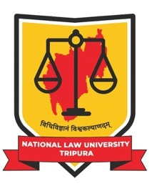

NATIONAL LAW UNIVERSITY, TRIPURA
(Established by Act No. 3 of 2022 of Tripura)

To,
The Registrar,
National Law University, Tripura

Sub: UNDERTAKING for Submission of Pending Documents for Admission to
B.A.LL.B. (Hons.)/LL.M. for 2026-27

I, Mr./Ms._________________________________________________have applied to ________________________________ programme of your university through CLAT 2026. However, at present, I am unable to submit the below-mentioned documents for verification.
I undertake to submit the requisite photocopy and original documents (as listed below), on or before August 31, 2026. If, I fail to submit the following documents [including original mark sheet and Degree/Passing Certificate of Graduation and other necessary documents]and prove my minimum eligibility for admission to the above-mentioned programme, I understand that my candidature may stand cancelled and I shall have no future claim to it. Besides, I also understand that this may lead to the forfeiture of the fees (deposited), etc.
I solemnly declare and inform you that I will fulfil all the eligibility conditions required to be met for admission to NLUT in the programme mentioned above.

List of documents not submitted/ not verified for admission process,
- _______________________________
- _______________________________
- _______________________________
- _______________________________
- _______________________________

I hereby undertake to submit the above-mentioned documents on or before August 31, 2026.

Yours faithfully,

Signature of the candidate:  Date: | Countersigned by Parent/Guardian  Signature of the Parent:  Name of the Parent:  Date:

